QIB UAT Deployment Procedure

Enhanced Passport Document Definition – Corporate Onboarding

1. Purpose
The purpose of this deployment is to update the Passport Document Definition in the Corporate Onboarding FlexiCapture project in the QIB UAT environment.
The enhanced Passport configuration is intended to improve Passport recognition and field extraction performance and address the Passport recognition failures observed during testing.
Step 1: Backup Existing Deployment Components
Before starting the deployment, take a backup of the existing configuration to ensure that the current version can be restored if required. On the D drive (D:/Backup find the Backup folder and make sure the following components are backed up)
  - Corporate Onboarding FC Project
Step 2: Deployment to QIB UAT Environment
Today, we will proceed with deploying the following components to the QIB UAT environment:
- The deployment includes the enhanced Passport configuration intended to improve Passport recognition and extraction results.
Please follow the below steps:

2.1 Update PASSPORT Batch Type – Image Processing
Open the PASSPORT Batch Type Settings.
Navigate to: Image Processing
Configure the image-processing options as shown in the deployment reference screenshot.

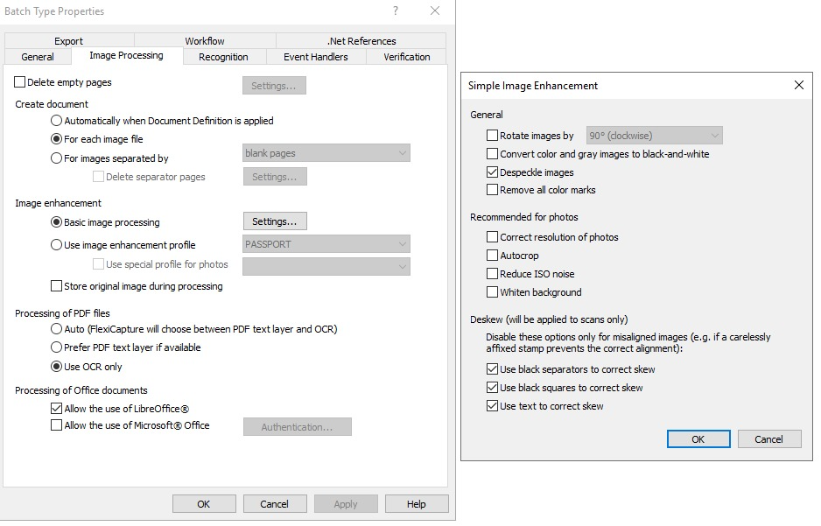
Save the changes.

2.2 Update PASSPORT Batch Type – Recognition
Within the PASSPORT Batch Type Settings, navigate to: Recognition
Configure the recognition settings as shown in the deployment reference screenshot.

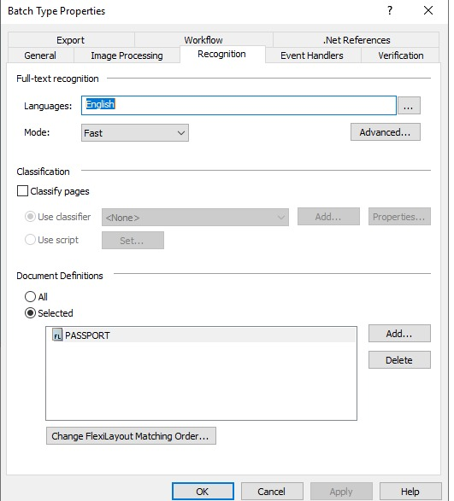
Save the changes.

2.3 Update PASSPORT Document Definition Properties
Open the PASSPORT Document Definition.
Navigate to: Document Definition Properties
Update/verify the configuration according to the deployment reference screenshot.

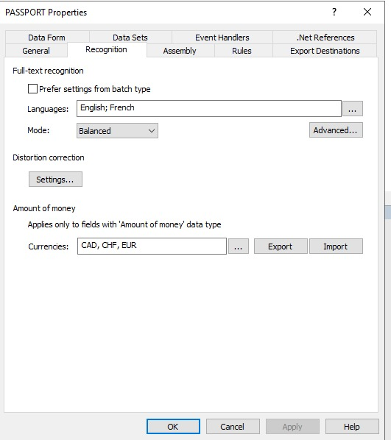
Save the changes.

2.4 Update Passport FlexiLayout
Update the existing Passport FlexiLayout (.afl) with the enhanced version provided for this deployment.
After updating the FlexiLayout:
- Save the Document Definition.
- Verify that the FlexiLayout is correctly associated with the PASSPORT Document Definition.
- Publish/update the Document Definition as required.
- Confirm that there are no configuration or compilation errors.
Step 3: Wrapper Service Configuration
- There are no changes in wrapper service and DLL projects.

Wrapper Service Endpoints
The following endpoints are used to interact with ABBYY FlexiCapture:
WPS Onboarding
http://<VmIPAddress>:<PortNumber>/FCServices/api/flexicapture/initiateOCR
Corporate Onboarding
http://<VmIPAddress>:<PortNumber>/FCServices/api/flexicapture/processOCR
The endpoints are exposed through the FCServices application deployed in IIS.

Routing
The existing routing is:
- initiateOCR – WPS Onboarding
- processOCR – Corporate Onboarding
Wrapper Service Project Deployment
- The document journey parameter has to pass the value as below:
- PASSPORT - processOCR
- {
- "DocumentType": "PASSPORT",
- "ChannelId": "MB2",
- "ReferenceId": "123456789",
- "DealerName": "",
- "DocumentJourney": "WPSOnboarding",
- "Param1" : "",
- "Param2" : "",
- "Param3" : "",
- "Param4" : "",
- "Param5" : "",
- "Data": "JVBERi0xLjUNJeLjz9MNCjE4IDAgb2JqDTw8L0xpbmVhcml6ZWQgMS9MIDY5Nj”}

- The routing controllers within the service are defined as:
  - initiateOCR– for WPS
  - processOCR – for CorporateOnboarding

Testing Scenarios
- Test the following document types with sample documents:
  - PASSPORT

